Patient Zero
Ape Rakelocked
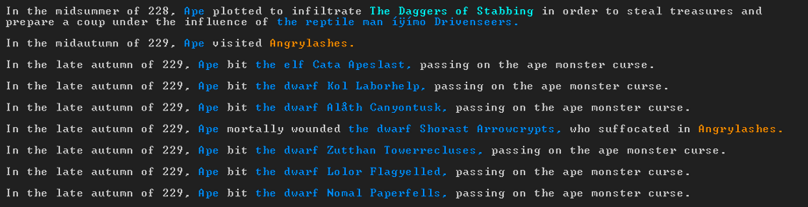
Mega spreader
Zutthan Towerrecluses
